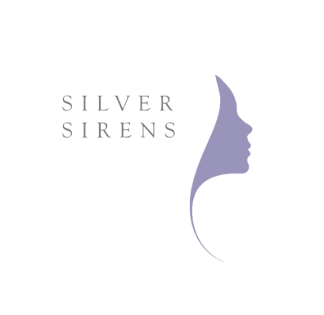
Nadine has been a well-known Interior Stylist in Australia for over 25 years. She has worked as a Stylist and Producer for many leading brands in Australia and overseas including Pottery Barn USA, Moet & Chandon, Wattyl Paints, Lexus, General Electric and Belle Property, to name a few.
Former Decorating Editor and Stylist/Producer with Belle Magazine for 8 years and former Style Director of Live This Magazine and TV Show for Murdoch Magazines and Channel Ten.
Until January 2017, Nadine had been full-time, Creative Director of Jamie Durie’s company Durie Design, where she has been a part of the company’s culture since it’s inception. As Creative Director she worked very closely alongside Principal, Jamie Durie, overseeing all creative content, product development, production and brand direction, and she and Durie are co-authors of Living Design, published by Penguin Lantern Books in October 2016. At the end of 2016 she moved from a full-time to a part-time role within the company.
In early 2017, Nadine started Bushtactics, a brand strategy, marketing, & communications consultancy business where she has a select number of like-minded clients she works very closely with and is also represented by Silverfox Management as an age-positive ambassador, influencer and model.
Nadine still acts as a Contributor to Belle Magazine and has several stories she has produced and written recently, the first of which was a travel story from Sri Lanka and published in the Aug/Sept 2018 issue.
She is currently at the tail end of a year and a half long book project for Bill and Lata Moss. The Moss’s own the historic property Dennarque Estate in Mt. Wilson (Blue Mountains) and are self-publishing an illustrated coffee table book capturing the stunning 25acre exotic and native garden throughout the four seasons of the year. Nadine is Project Manager and Ghost Writer. The book will be ready to go to print mid- February 2019.

BUSHTACTICS
M +61 411 174 113
E nadz@bushtactics.com.au

