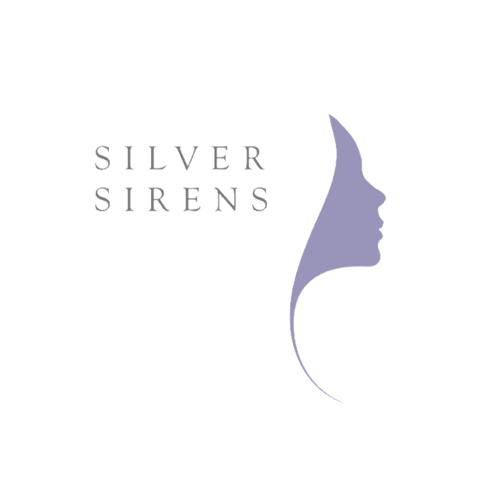

As the founder of Sacred Women's Business Coaching, Lisa Fitzpatrick supports coaches, leaders, visionaries, yoga teachers, spiritual teachers, writers, healers and women in service-based businesses the art and science of embodied leadership and holistic success. Sacred Women's Business Coaching makes a fierce stand for high achieving, conscious women in leadership and business to tap into their feminine wisdom and find their leading edge.

Sacred Women's Business Coaching was a finalist in two categories of the 2015 Ausmumpreneur Awards and won a bronze in the Service Business category. Sacred Women’s Business was proud to be an official Ausmumpreneur expert in 2016.

Lisa Fitzpatrick is a contributing author to the best-selling books Manifesting in High Heels – secret rituals to achieve success and The Nurtured Woman’s Book Series. Lisa’s book Healing the Heart of Your Business – sustainable success for heart-centred women was recommended as one the top ten inspiring books, December 2015 in the Aspire magazine.

Lisa believes that spiritually aware and sensitive women who are prepared to do the inner and outer work of realising their life purpose will help to heal our troubled world, supporting a feminine shift towards greater balance and equality for all beings. The more awakened women who take empowered leadership positions in the world and through their businesses, the better our world will be.
Lisa is a certified coach, best-selling author, yoga teacher, workshop facilitator, keynote speaker, registered Physiotherapist and mother. She lives in a subtropical paradise near Byron Bay.

Lisa’s website: http://www.LisaFitzpatrick.com.au
Instagram: www.instagram.com/sacredwomensbusiness
Facebook: www.facebook.com/thenewfeminineleader

