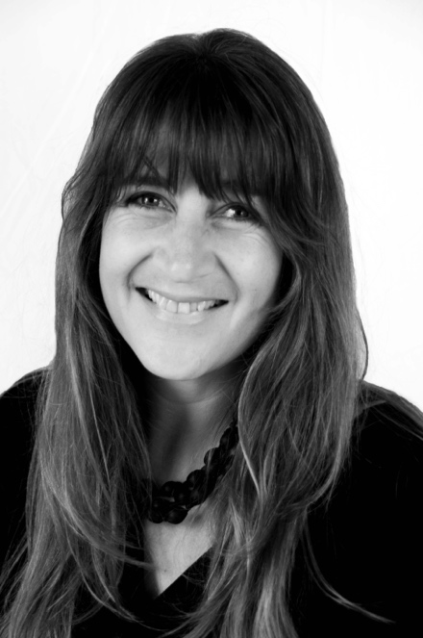
Rowena Hall BIO

Rowena Hall is a Sydney born photo-media artist whose career has involved a demanding work schedule within the Arts Sector – working for organisations such as the Australian Centre for Photography (ACP); the Australian Film, Television and Radio School (AFTRS); and more recently the City of Sydney Council at Pine Street Creative Arts Centre as the Adults Program/Gallery Coordinator. During her career she has balanced her work life with periodic art-making that includes completing a Masters by Research at the Sydney College of Arts where she produced her highly esteemed photographic series, History Bearing, which was launched as a showcased solo-exhibition in the Head On Photo Festival in 2012.

The work History Bearing was designed to reveal historical stories (850 AD to the 1960s) of women with emphasis on their fertility. This dynamic series of images readjusts the way the female body has historically been represented by including fertility as part of the norm, as opposed to treating it as something to be excluded. Since the launch of History Bearing Rowena was a finalist and winner of the Ryde City Council Art Prize in 2013 for her image, Franco 1962: Spanish Bride. The competition theme was ‘stopping violence towards women’, and the judges’ comments being that this image “nailed the message clearly and poignantly”. In 2014, Rowena was artist in residence at the Children of Southeast Asia Refuge (COSA), Baan Yuu Suk based one hour north from Chang Mai, Thailand. During this month Rowena travelled to remote villages with refuge staff and a visiting film crew who were making a documentary about the then COSA Founder, Mickey Choothesa. The work and research done in Thailand is part of an ongoing interest in human rights (particularly women and girls) under the working title of Playing Witness.

In 2017 Rowena accepted an offer of scholarship from the Australian National University School of Art to pursue a new photo-media series as a full-time PhD candidate with the Digital and Photographic Media Department and relocated from Sydney to the Southern Tablelands. This current research project is titled: ‘Familial Colonial Histories in Art: Re-presenting Colonisation and Settler Relationships’. The project aims to create a visual narrative work that investigates Australian colonialism and historical truth telling by researching Rowena’s personal West Australian paternal family history using historical records such as photographs, letters and diaries as well as published texts and other sources (including oral histories) that examine and reframe the colonial narrative. This research includes frequent field work and relationship building with First Nations Peoples so that the work is collaborative and examines a selection of interpretations of found stories. The work’s emphasis is to focus on the untold truths and unexplored, intimate spaces in a feminist and reconciliatory context.

Contact: rowena.hall@anu.edu.au
www.rowenahall.com

