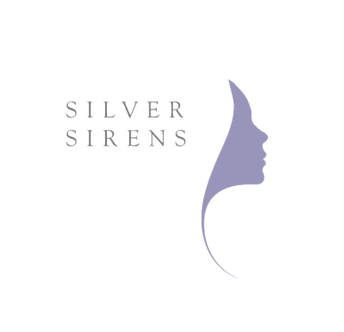
Robyn Chuter Bio
Robyn Chuter is a Certified Lifestyle Medicine Practitioner, naturopath, nutritionist and counsellor who runs two busy practices, in Sydney and on the Gold Coast, and also consults online with clients all over the world. She specialises in helping smart women who are struggling with their weight, health and eating habits to become their healthiest and happiest selves. Learn more about Robyn and how you can work with her, one to one or in one of her group programs, at www.empowertotalhealth.com.au

robyn@empowertotalhealth.com.au

